MS.Barrow’s newsletter
  - December 18th , 2017

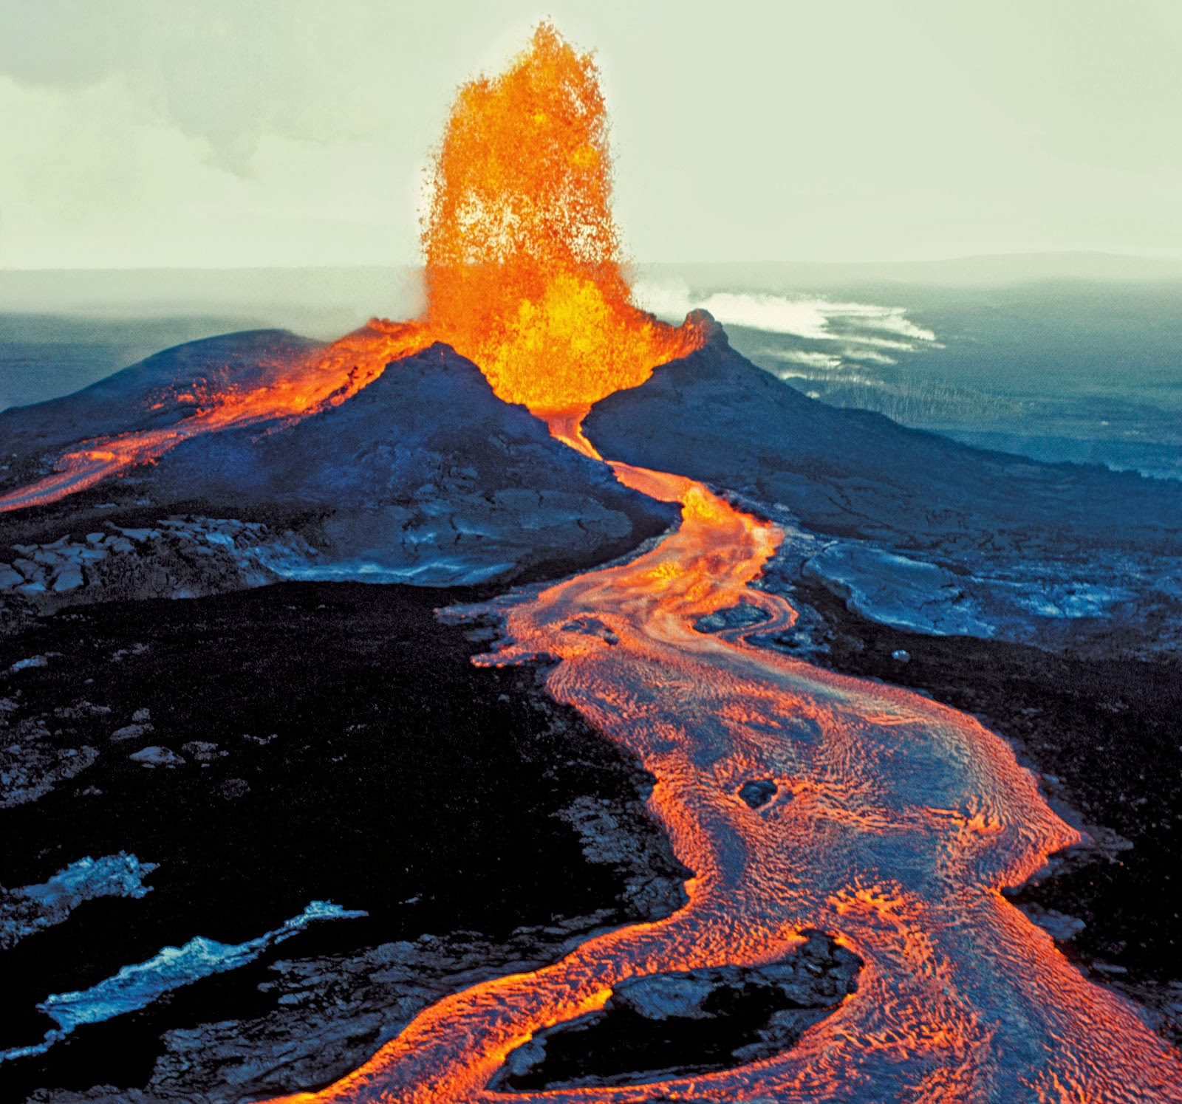  Classroom News:  Next week’s assessments:  - Test/Quiz: Test chapter 6 Wednesday  - Classwork/Project: Students will work on Chapter 6 lesson two key concept builder. I will be checking that students are actively working it during class as a classwork grade this week.  - Any and all missing work MUST be turned in to me by Wednesday for partial credit, no exceptions | Chapter 6 lesson 2:  In this lesson we discover how volcanos form. We look at what factors contribute to the unique eruption styles of different types of volcanos. We will have a test on Wednesday on volcanos as well as what we learned from lesson one, earthquakes.  EVENT INFORMATION:  - Check out some great PTO events coming up on the PTO news page : https://www.smore.com/dw4gs  - Ugly sweater day! : With winter break quickly approaching, students may wear jeans and ugly sweaters/tee-shirt on the half day, Thursday. This is a HOLIDAY event. Students are not to just “dress down”. Student need to either be participating in the holiday spirit or are expected to be in full uniform.

